**Họ và tên: Ngô Phương Thanh**

**Lớp: DHKL16A1HN**

**Mã sv: 22174600049**

**BÀI TẬP THỰC HÀNH MÔN MẠNG MÁY TÍNH**

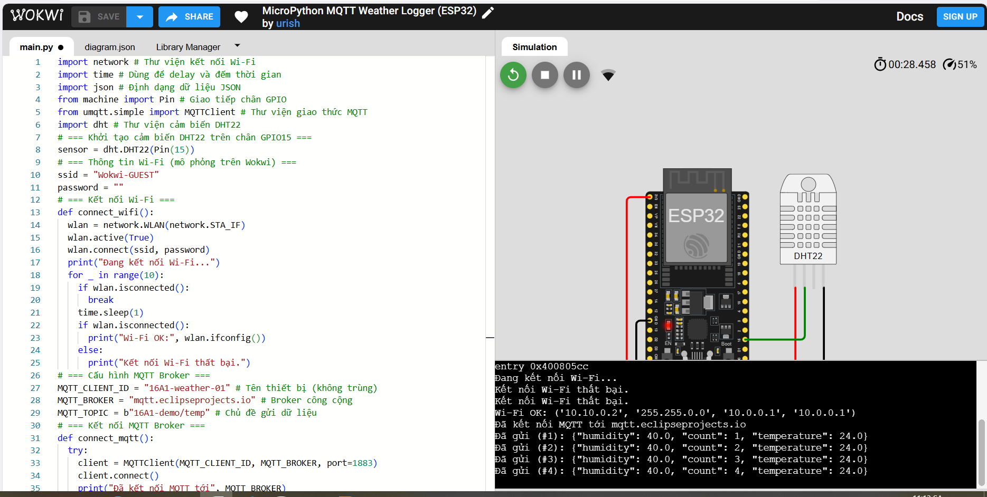

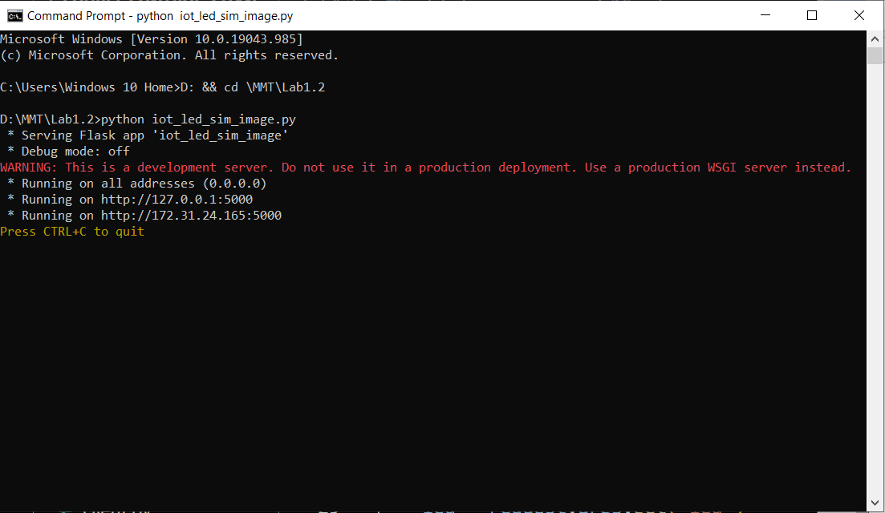

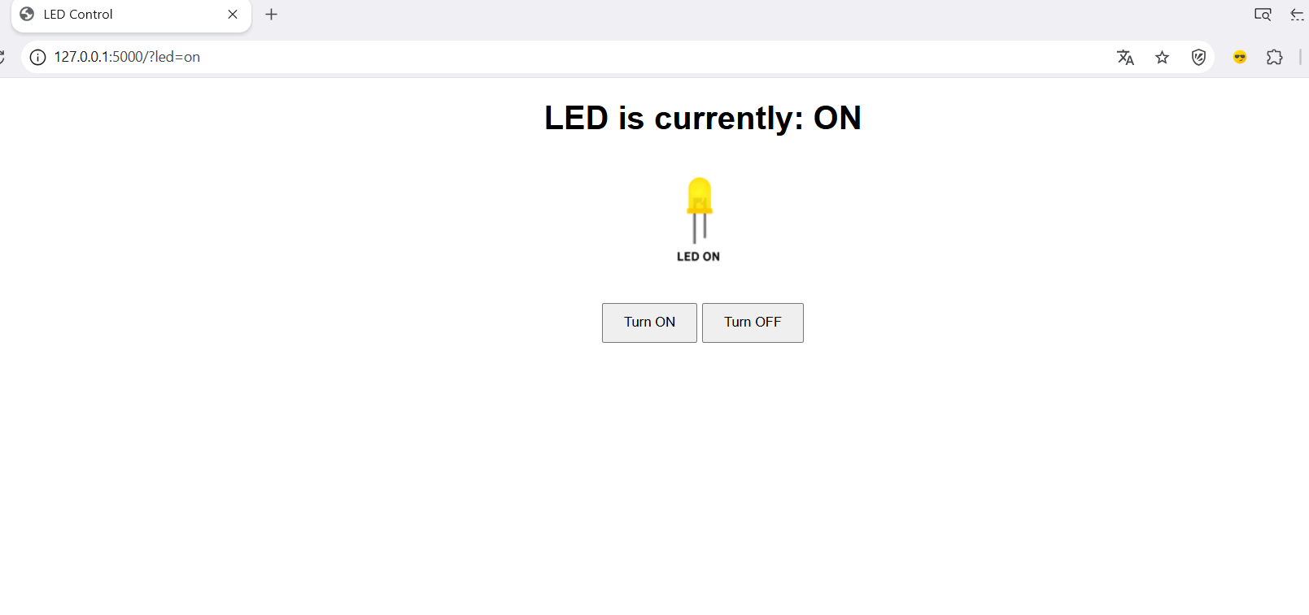

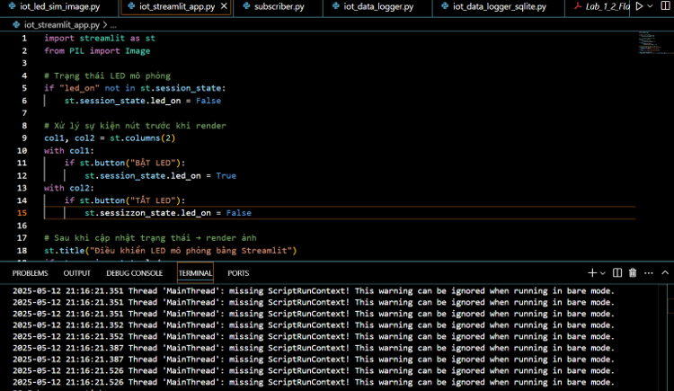

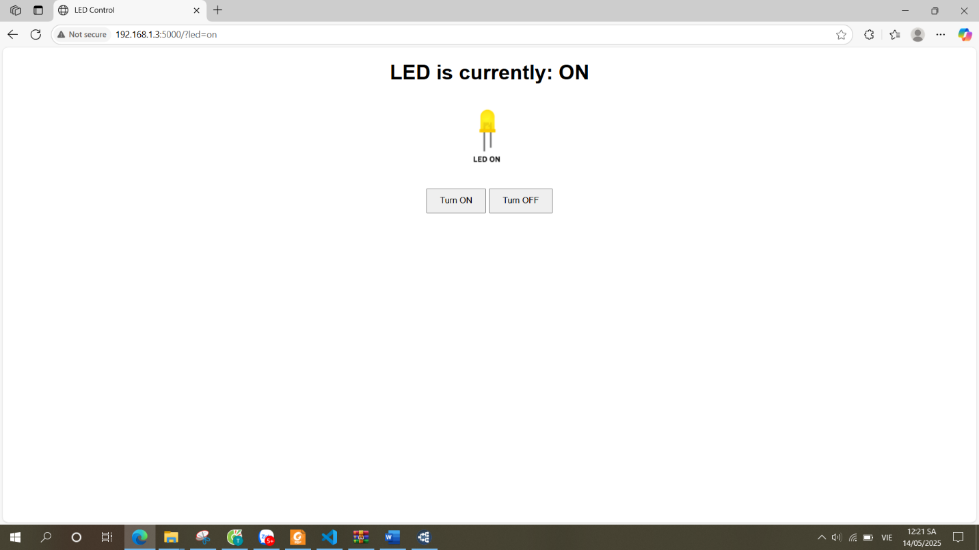

2.4.a

F:\mang_may_tinh\iot_data_logger.py

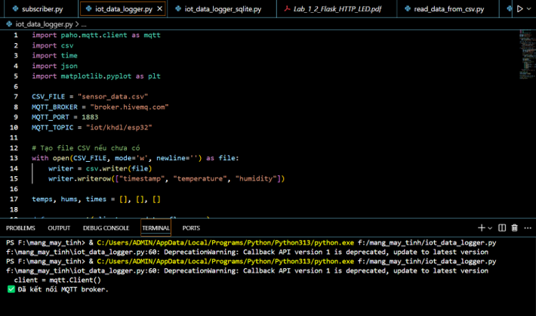

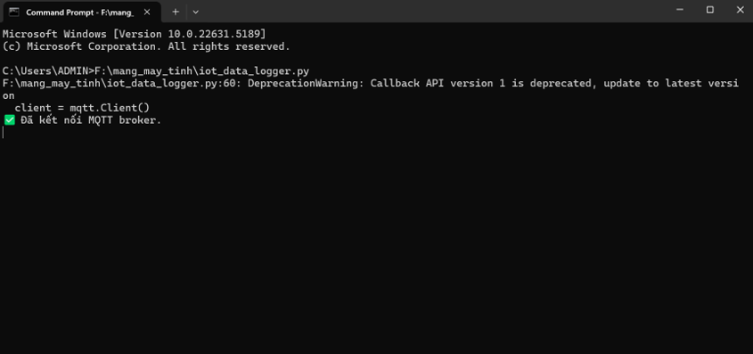

2.4.b.F:\mang_may_tinh\iot_fake_publisher.py

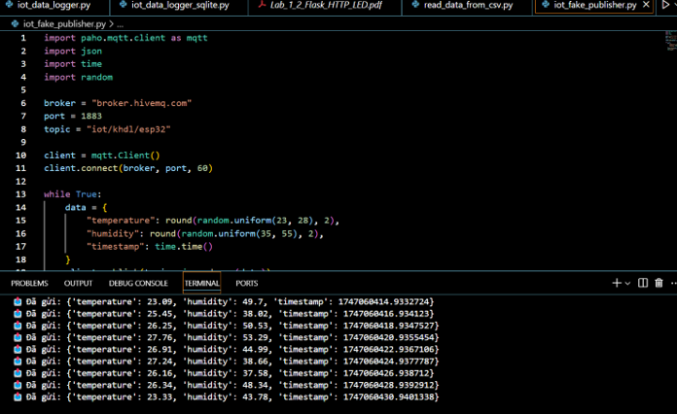

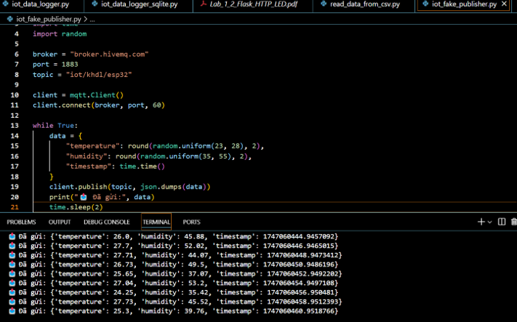

2.4.c

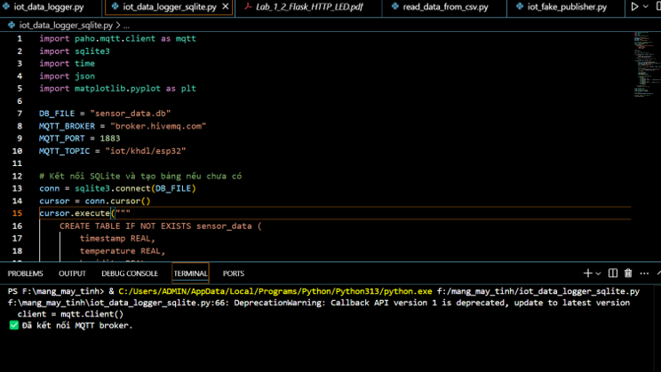

2.4.d.

F:\mang_may_tinh\read_data_from_csv.py

